Ex.No. 1

Date:

**DDL Commands – CREATE, ALTER, DROP**

1. Create a table name STUDENT with following structure.

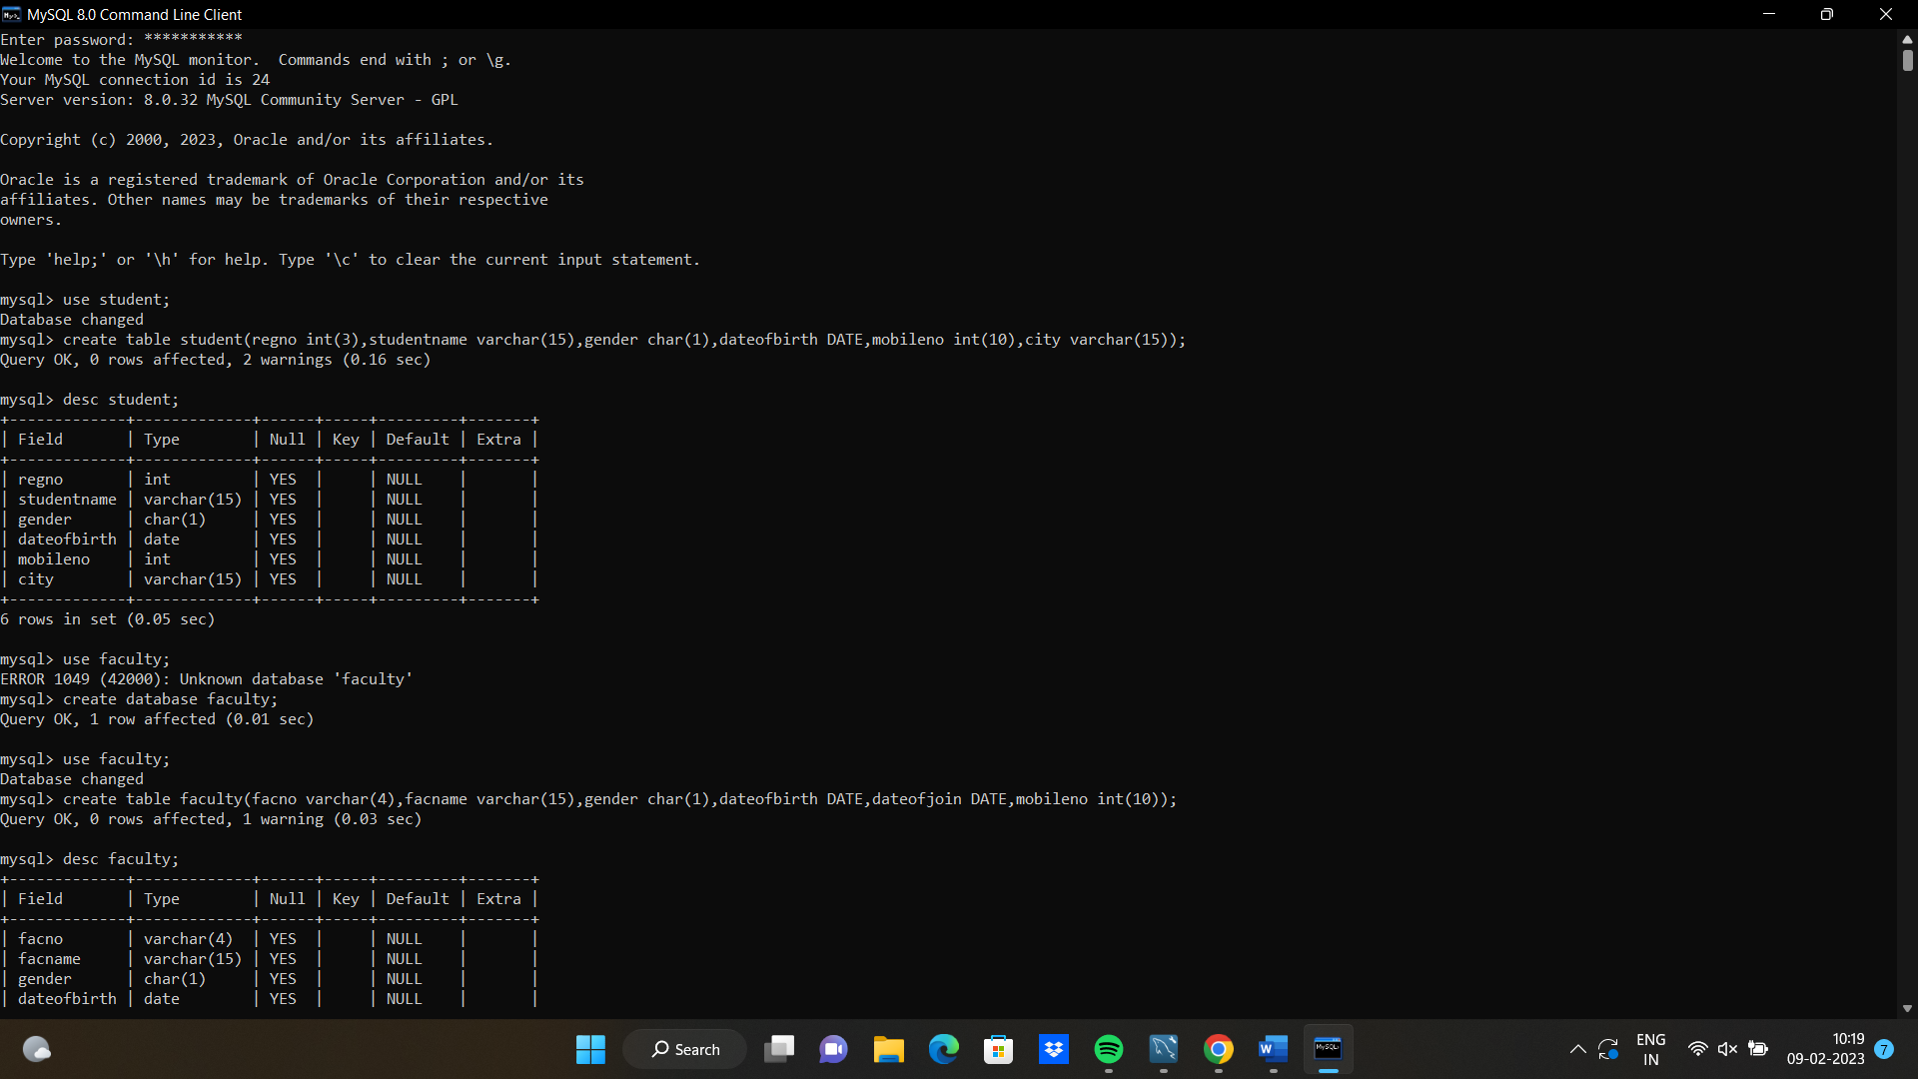

2) Create a table name FACULTY with following structure.

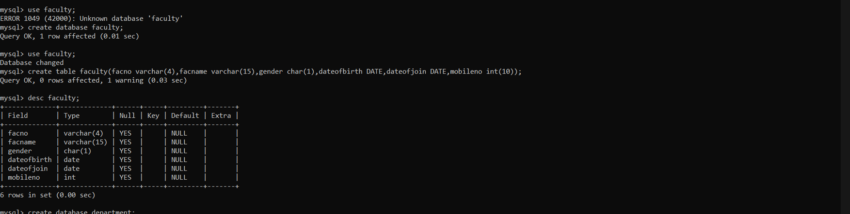

3) Create a table name DEPARTMENT with following structure.

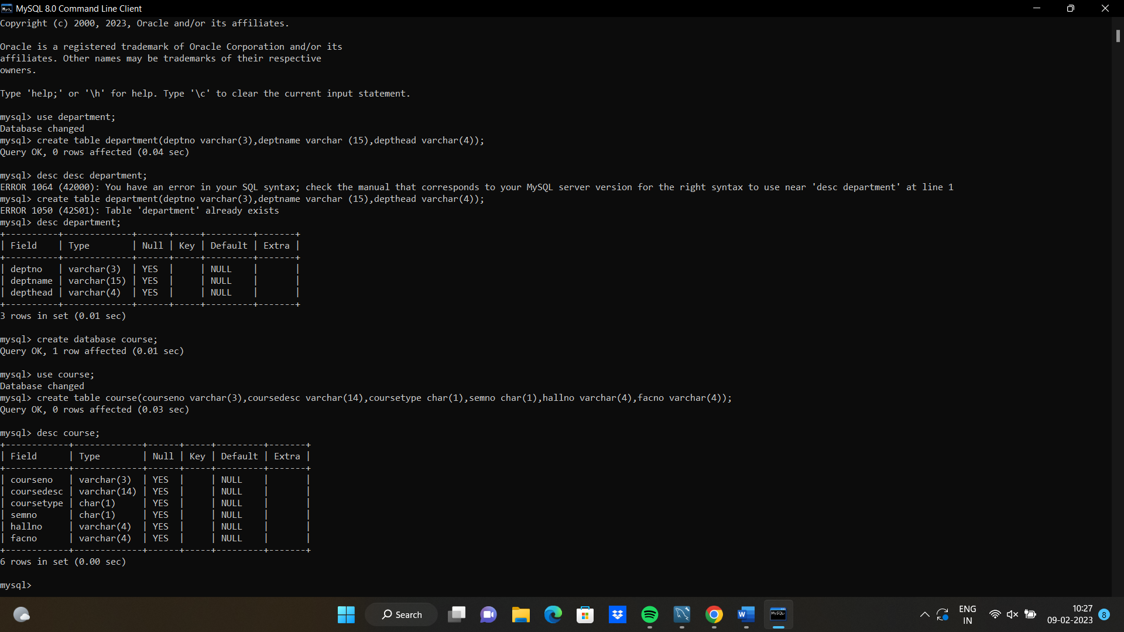

4) Create a table name COURSE with following structure.

